**EXAMPLE 1 :**

*Problem Statement*

Calculate area of a rectangle

*Analysis (IPO)*

Input : length, width

Process : area = length X width

Output : area

*Algorithm (Pseudocode & Flowchart)*

1. *Flowchart*

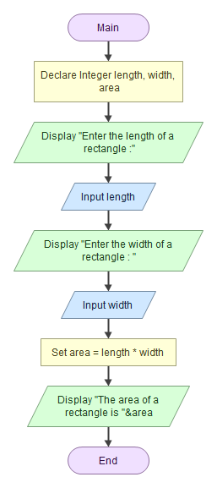

1. Pseudocode

Start/begin

Declare Integer length, width, area

prompt "Enter the length of a rectangle :"

read length

prompt "Enter the width of a rectangle : "

read width

calculate area = length * width

display "The area of a rectangle is ", area

Finish/end

***Sample of output :***

*Sample 1*

Enter the length of a rectangle :

4

Enter the width of a rectangle :

5

The area of a rectangle is 20

*Sample 2*

Enter the length of a rectangle :

10

Enter the width of a rectangle :

20

The area of a rectangle is 200

**EXAMPLE 2 :**

Problem Statements :

Your coding needs to enter the name of the item, quantity that you want to purchase and price of the item/unit. You need to calculate the item price and given the GST rate is 3.5%. Calculate the total price of the item together with the GST charges. Display the item name, quantity purchased, price per item, total price before GST, GST charges and total price with GST.

*Analysis (IPO)*

Input : itemName, quantity, priceperunit

Process : calculate totalprice = quantity X priceperunit

gstTax = totalprice X 0.035

totalwithGST = totalprice + gstTax

Output : itemName, quantity, priceperunit, totalprice, gstTax, totalwithGST

*Algorithm (pseudocode and flowchart)*

*Flowchart*

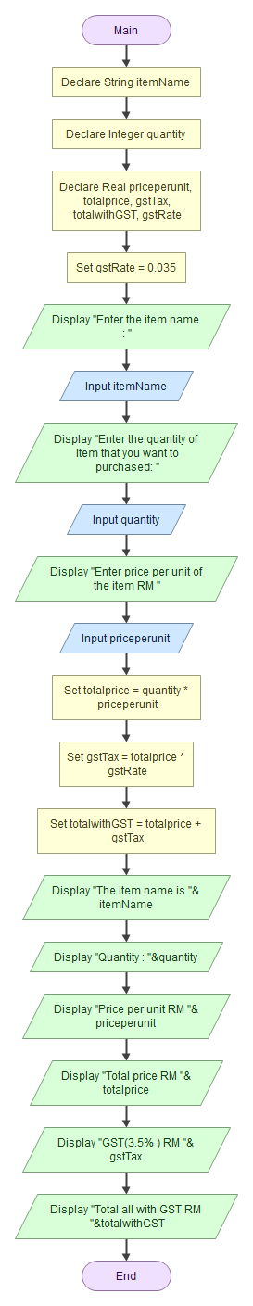

*Pseudocode*

start

Declare String itemName

Declare Integer quantity

Declare Real priceperunit, totalprice, gstTax, totalwithGST, gstRate

Initial/set gstRate = 0.035

prompt "Enter the item name : "

read itemName

prompt "Enter the quantity of item that you want to purchased: "

read quantity

prompt prompt "Enter price per unit of the item RM "

read priceperunit

calculate totalprice = quantity * priceperunit

calculate gstTax = totalprice * gstRate

calculate totalwithGST = totalprice + gstTax

Display "The item name is ", itemName

Display "Quantity : ", quantity

Display "Price per unit RM ", priceperunit

Display "Total price RM ", totalprice

Display "GST(3.5% ) RM ", gstTax

Display "Total all with GST RM ", totalwithGST

Finish

Sample output

*Sample 1*

Enter the item name :

pen drive

Enter the quantity of item that you want to purchased:

2

Enter price per unit of the item RM

35

The item name is pen drive

Quantity : 2

Price per unit RM 35

Total price RM 70

GST(3.5% ) RM 2.45

Total all with GST RM 72.45

*sample 2:*

Enter the item name :

cd rom

Enter the quantity of item that you want to purchased:

10

Enter price per unit of the item RM

0.50

The item name is cd rom

Quantity : 10

Price per unit RM 0.5

Total price RM 5

GST(3.5% ) RM 0.175

Total all with GST RM 5.175

**Example 3:**

Write a complete documentation such as the IPO, pseudocode, flowchart and sample of output for the following problem statements. You need to develop one simple application to obtain three integer numbers from the user and calculate the summation & multiplication of three numbers.

Display the numbers that user has entered and the result of summation & multiplication

*IPO*

Input: number1, number2, number3  
Process: Calculate sum = number1 + number2 + number3  
 Calculate multiplication = number1 * number2 * number3

Output: number1, number2, number3, sum, multiplication

*Flowchart*

*Pseudocode*

Start

Declare Real number1, number2, number3, sum, multiplication

Prompt "Enter the first number: "

Read number1

Prompt "Enter the second number: "

Read number2

Prompt "Enter the third number: "

Read number3

Calculate sum = number1 + number2 + number3

Calculate multiplication = number1 * number2 * number3

Display "Your first number is: ", number1

Display "Your second number is: ", number2

Display "Your third number is: ", number3

Display "The sum of the three number is: ", sum

Display "The multiplication of the three number is: ", multiplication

*Sample of Output (1)*

Enter the first number:

1

Enter the second number:

2

Enter the third number:

3

Your first number is: 1

Your second number is: 2

Your third number is: 3

The sum of the three number is: 6

The multiplication of the three number is: 6

*Sample of Output (2)*

Enter the first number:

10

Enter the second number:

12

Enter the third number:

6

Your first number is: 10

Your second number is: 12

Your third number is: 6

The sum of the three number is: 28

The multiplication of the three number is: 720